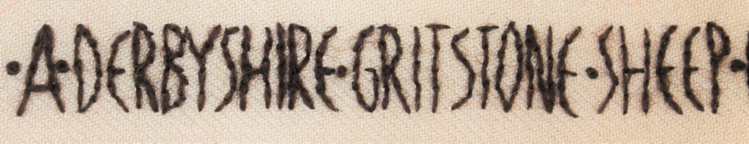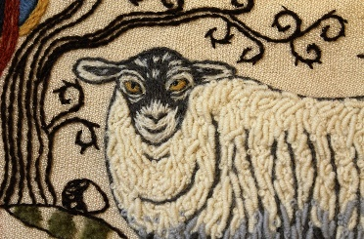
Crewelwork Weekend Programme
The Haybarn at Beechenhill Farm
Tutored by Cathy Reavy, the programme is designed to allow you maximum sewing time, whilst incorporating relaxing breaks for refreshments, short talks, and simply give you time to enjoy the wonderful environment you are in. You may wish to continue sewing during the evening in your room or at home, but this is not obligatory!
Friday
15.00 Welcome with tea/coffee & home-made cakes in the
Hayfield Barn Gallery (residential students may check in from 14.00).
15.30 Brief Introduction to the weekend and to Beechenhill.
Overview of the stitches and wools.
16.00 Begin stitching!
17.30 Finish

Saturday

09.30 Arrival & tea/coffee
09.45 Continue stitching!
11.15 Tea/coffee & home-made biscuits
11.30 Continue stitching!
13.00 Light lunch of home-made soup, home-made bread & local cheese
Tea/coffee afterwards with the opportunity to admire Sue Prince’s
artwork & prints displayed in the Gallery.
13.45 Continue stitching!
14.45 Talk – more about Jacobean crewelwork
15.15 Tea/coffee & home-made cakes
15.30 Continue stitching!
16.30 Finish
©2016

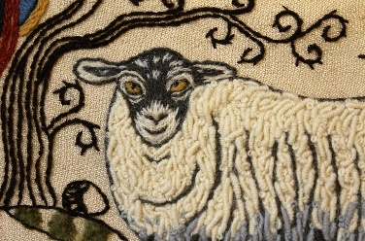

Sunday

09.30 Arrival & Tea/coffee
09.45 Continue Stitching!
11.15 Tea/coffee & home-made biscuits
11.30 Continue Stitching!
12.30 Talk – how to wash, stretch and finish off your embroidery.
13.00 Light lunch of home-made soup, home-made bread & local cheese.
Tea/coffee afterwards
13.45 Continue Stitching!
15.00 Tea/coffee & home-made cakes
15.30 Finish

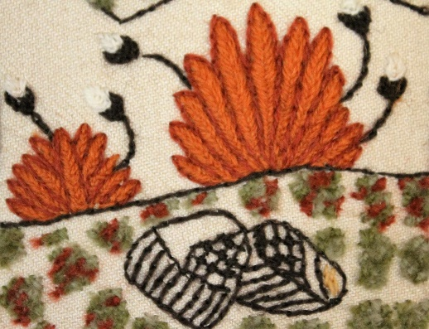

©2016

