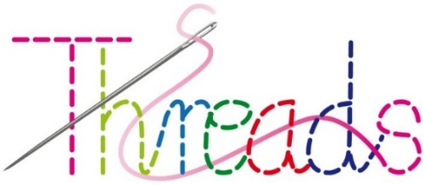
Additional Arrangements / Terms during the Covid-19 Pandemic

- Payment for workshop places is required in full 3 weeks in advance. If payment is not received by 3 weeks before the workshop date, your place will be cancelled and may be offered to another person.

- Should you decide to cancel your booking up to 1 week before the workshop date, your payment will be refunded in full on request. Alternatively you will have the option of transferring your booking to a suitable alternative workshop, or receive a kit with online tutorial together with any balance payment. If you need to cancel within the week immediately before the workshop date, you will be sent the kit with online tutorial and no refund will be due. Different arrangements will apply to weekend workshops and attendees will be notified individually.

- We reserve the right to cancel a workshop should there be insufficient demand, or as a result of any other extenuating circumstances. In such an event, payment will be refunded in full as soon as is reasonably possible after cancellation.

- Threads will adhere to the Government’s guidelines for the safe use of Community facilities, in conjunction with Alstonefield Village Hall.

- You must not enter the premises if you or anyone in your household has Covid-19 symptoms. If you develop Covid-19 symptoms within 10 days of visiting the premises, alert Test, Track and Trace, and also Cathy or John Reavy of Threads workshops on 01335 310125 or 07732 222206.

- The Hall will have been cleaned before your arrival (including tables, door handles, light switches, window catches, toilet handles & seats, washbasins & surfaces).

- You will be asked to use hand sanitizer on entering and exiting the premises, which will be provided. In addition you should wash your hands often.

- Social distancing will be implemented so that a minimum of a 2 metre distance is maintained between each attendee. If you are from the same household or bubble, you may of course sit together if we are notified in advance.

- The wearing of face masks is required from 8th August 2020. Please bring a face mask with you. Obviously we will take a common sense approach and you will not be able to wear masks whilst we are taking refreshments for example.

- No more than 2 people are permitted to be in the toilet area at the same time (1 in the disabled toilet).

- Embroidery demonstrations will be projected on to a large screen by pre-recorded video so that no-one has to gather in groups in order to see the work process. The tutor (Cathy Reavy) will be available to provide additional instructions as needed.

- Attendees must bring their own embroidery equipment including hoops, scissors, pins & pencil. Everyone will be notified what to bring by e-mail.

- Beverages, biscuits & cake will be served from behind the bar in the kitchen area. All cutlery, plates, cups etc. will be washed using the dishwasher and anyone preparing drinks and food will wear a mask or visor in the kitchen. Attendees wishing to bring their own cups, plates etc. may of course do so. Coffee & tea will be poured for you. Only organisers will be allowed to enter the kitchen. The fridge will not be available to store lunches.

- A display of embroideries for future workshops will be laid out in the Hall as normal. These should not be touched.

- Items will be available to purchase as normal, together with charity items for donations. These can only be handled and shown to you by the workshop Tutor
and can be placed directly into a bag for you.

- These arrangements will be constantly reviewed and updated in line with any changes to Government guidelines.

8th August 2020

